 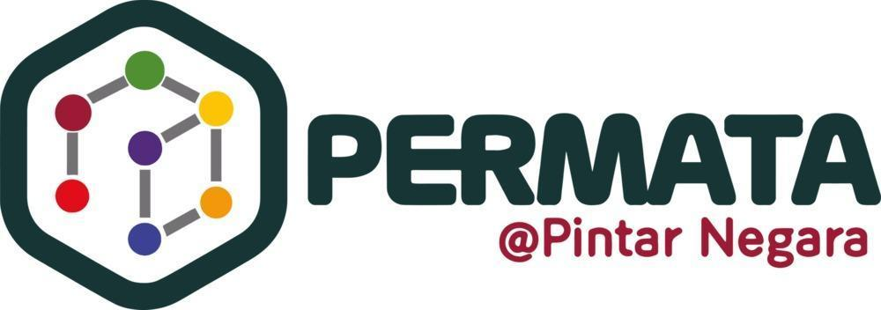

**DIGITALINNOVATORPROGRAMME(DIP)**

**COMPUTER SCIENCE 1 PSCS2014**

**COMPUTER SCIENCE  
SEMESTER 2 PART 2**

**TASK 3 (10% CARRYMARKS)**

**SQL EXERCISE : LIBRARY DATABASE**

# PREPARED BY: NUR MAHEERAH BINTI MOHAMMAD SAIFROL

# CLASS: 1K4

#### 

#### **TABLE OF CONTENT**

#### **1.0 DATABASE STRUCTURE**

##### 1.1 Creating Database

##### 1.2 Creating Table

#### **2.0 DATA MANAGEMENT**

#### **3.0 QUERY OPERATIONS**

##### 3.1 List and Find Books Query

##### 3.2 Update Query

##### 3.3 Delete Query

#### **4.0 RESULTS DOCUMENTATION**

##### 4.1 Final Result

##### 4.2 Result after Deleted a Book

##### 4.3 Result Re-Add Deleted Book

#### **1.0 DATABASE STRUCTURE**

#### **1.1 Creating Database**



##### **1.2 Creating Table**

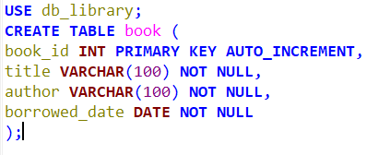

#### **2.0 DATA MANAGEMENT**

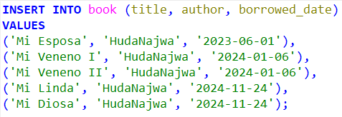

#### **3.0 QUERY OPERATIONS**

##### **3.1 List and Find Books Query**

##### 



##### **3.2 Update Query**

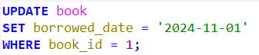

##### **3.3 Delete Query**



#### **4.0 RESULTS DOCUMENTATION**

##### **4.1 Final Results**

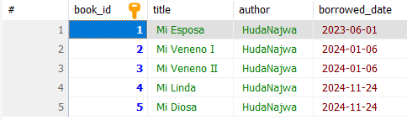

##### **4.2 Result after Deleted A Book**

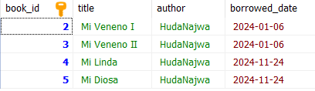

##### **4.3 Result After Re-Add A Deleted Book**

